**SAYISAL İŞARET İŞLEME LABARATUARI ÖDEV 2**

**SORU 1)a.**

Hanning penceresi kullanılarak 2500 Hz kesim frekanslı 8000 Hz örnekleme frekanslı 65 katsayılı filtreyi matlab da tasarladık.

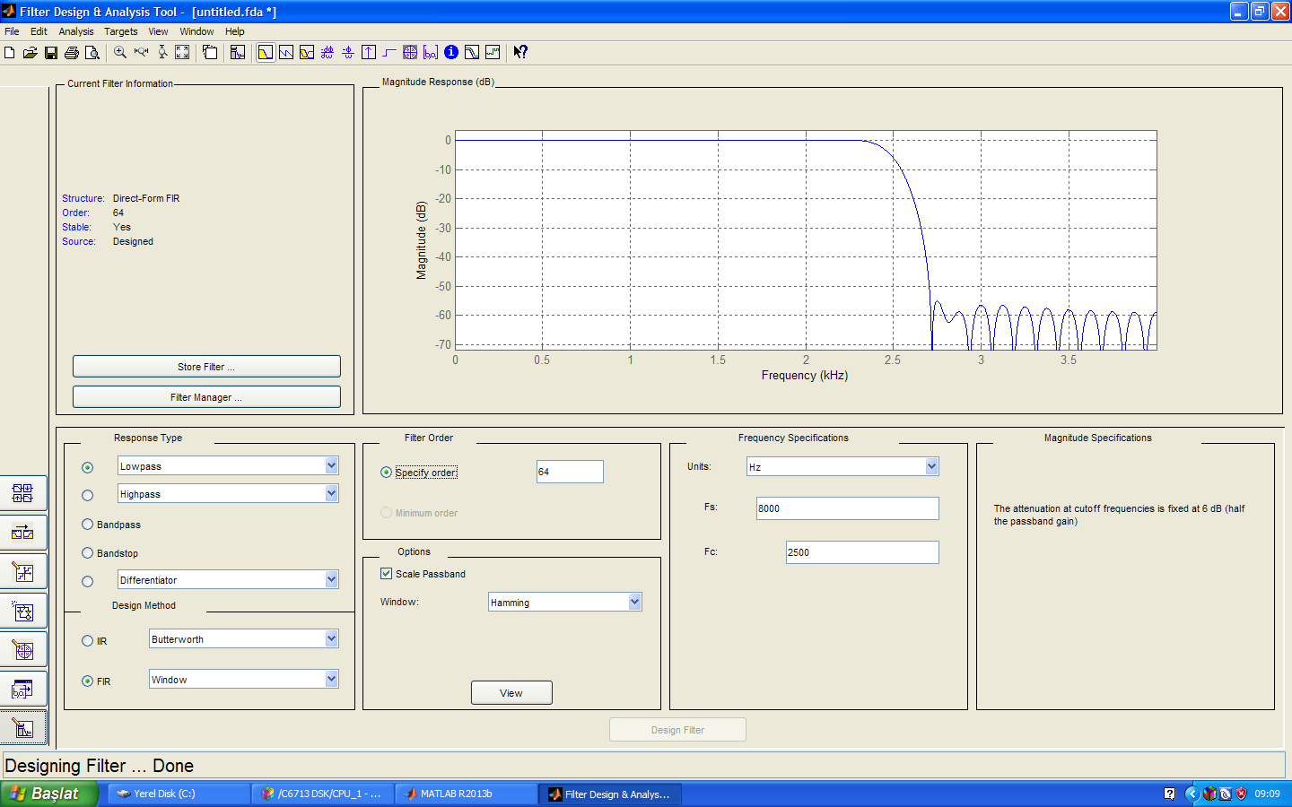

firprnbuf.c dosyasını kullanarak gerçekleştirdik ve osiloskop görüntüsünü aldık.

// program firprnbuf.c

#include "DSK6713_AIC23.h" // codec support

Uint32 fs=DSK6713_AIC23_FREQ_8KHZ; //set sampling rate

#define DSK6713_AIC23_INPUT_MIC 0x0015

#define DSK6713_AIC23_INPUT_LINE 0x0011

Uint16 inputsource=DSK6713_AIC23_INPUT_LINE; // select line in

#include "Hamming.cof" //filter coefficient file

#include "noise_gen.h" //support file for noise sequence generation

int fb; //feedback variable

shift_reg sreg; //shift register

#define NOISELEVEL 8000 //scale factor for +/- 1 noise sequence

float x[N]; //filter delay line

#define YNBUFLENGTH 1024

float yn_buffer[YNBUFLENGTH];

short ynbufindex = 0;

int prand(void) //pseudo-random noise generation

{

int prnseq;

if(sreg.bt.b0)

prnseq = -NOISELEVEL; //scaled negative noise level

else

prnseq = NOISELEVEL; //scaled positive noise level

fb =(sreg.bt.b0)^(sreg.bt.b1); //XOR bits 0,1

fb^=(sreg.bt.b11)^(sreg.bt.b13); //with bits 11,13 -> fb

sreg.regval<<=1; //shift register 1 bit to left

sreg.bt.b0=fb; //close feedback path

return prnseq;

}

void resetreg(void) //reset shift register to nominal values

{

sreg.regval=0xFFFF; //initial seed value

fb = 1; //initial feedback value

}

interrupt void c_int11() //interrupt service routine

{

short i; //declare index variable

float yn = 0.0;

x[0] = (float)(prand()); //get new input into delay line

for (i=0 ; i<N ; i++) //calculate filter output

yn += h[i]*x[i];

for (i=(N-1) ; i>0 ; i--) //shuffle delay line contents

x[i] = x[i-1];

output_left_sample((short)(yn)); //output to codec

yn_buffer[ynbufindex++] = yn;

if(ynbufindex >= YNBUFLENGTH) ynbufindex = 0;

return; //return from interrupt

}

void main()

{

resetreg(); //reset shift register to nominal values

comm_intr(); //initialise McBSP and AD535

while (1); //infinite loop

}

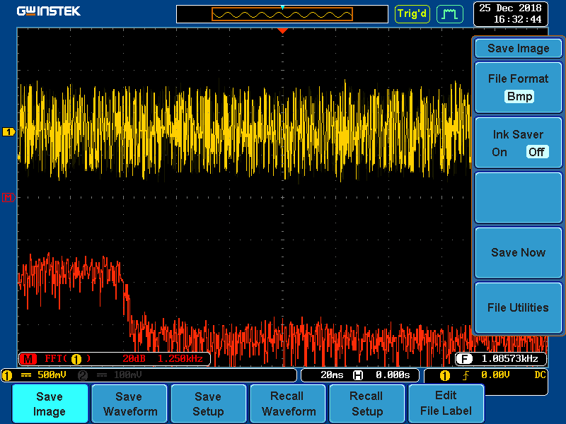

**Soru 1)b.**

A şıkkında hanning penceresi kullanarak yaptığımız filtre karakteristiğini Hann ve kaiser penceresi kullanarak tasarladık.

HANN

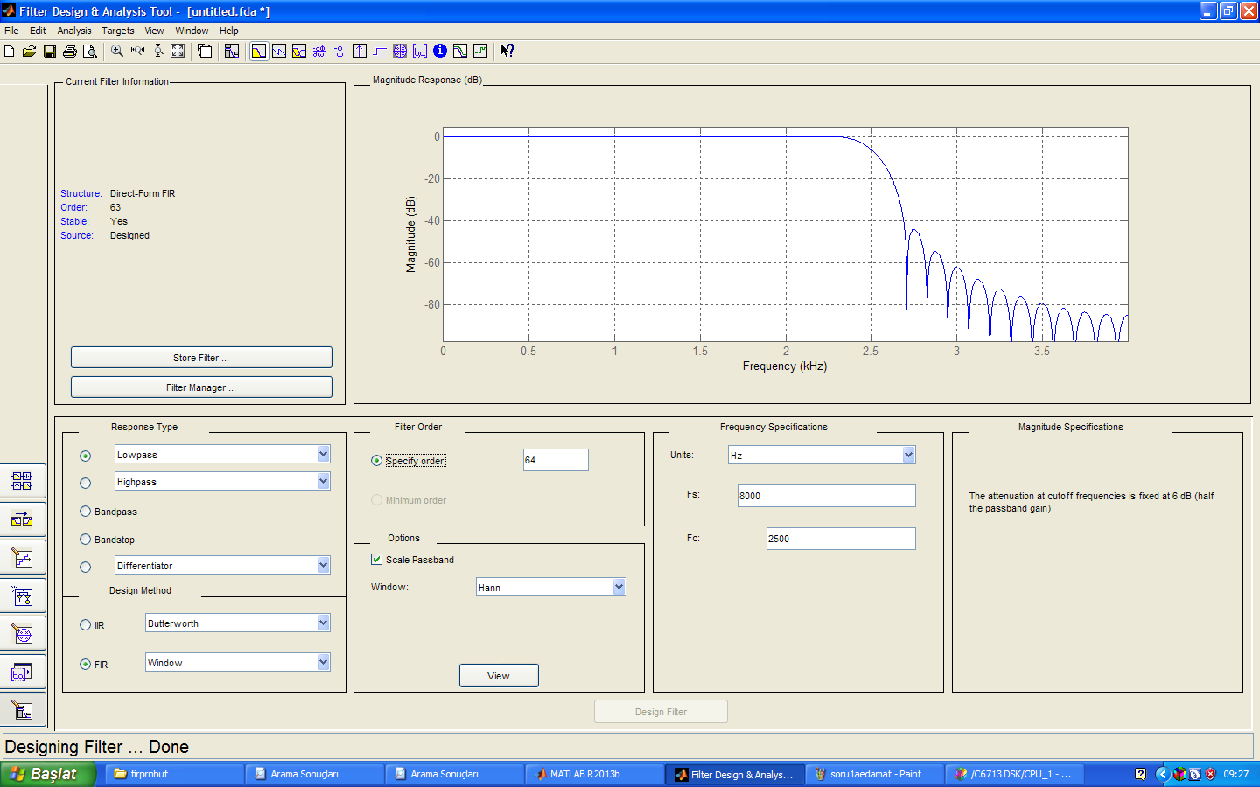

KAİSER

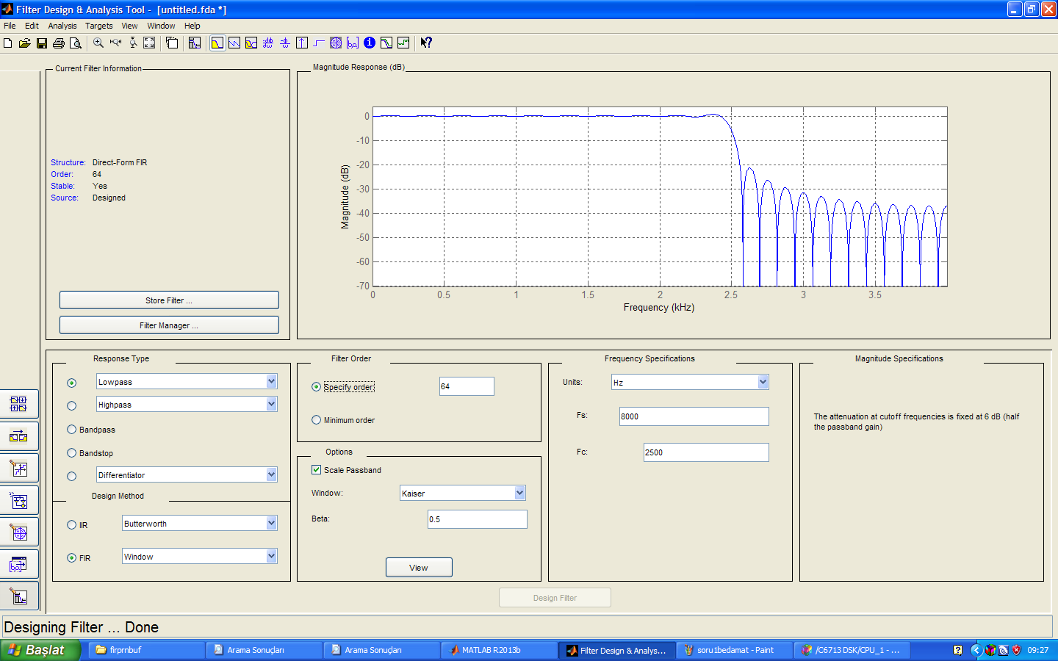

**Soru 2)**

2500 Hz ve 3500 Hz iki geçirme bandına sahip fir filtreyi Matlab da tasarladık.

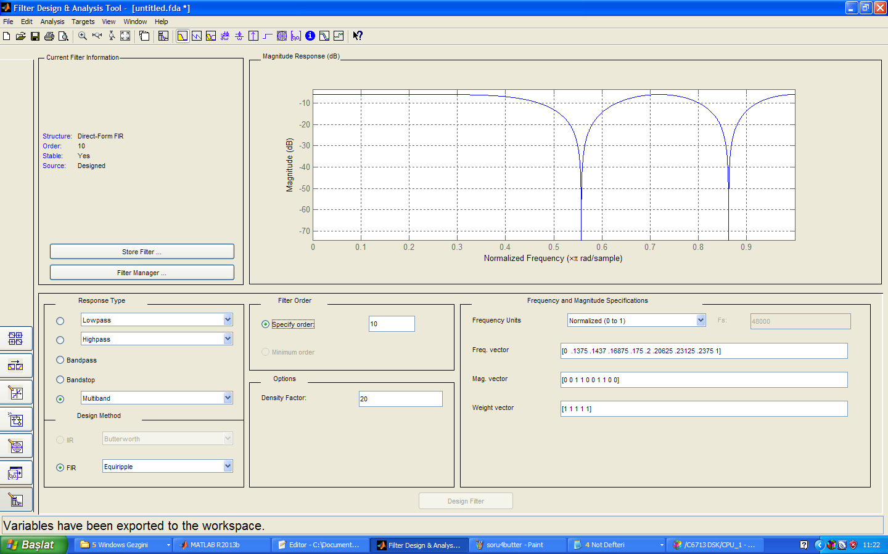

**Soru 3)**

Firprn.c programında C kodlu üretilen gürültü yerine ASM kodlu gürültüyü üreten kodu yazdık.

// program fir.c

#include "DSK6713_AIC23.h" // codec support

Uint32 fs=DSK6713_AIC23_FREQ_8KHZ; //set sampling rate

#define DSK6713_AIC23_INPUT_MIC 0x0015

#define DSK6713_AIC23_INPUT_LINE 0x0011

Uint16 inputsource=DSK6713_AIC23_INPUT_LINE; // select line in

#include "bs2700f.cof" //filter coefficient file

float x[N]; //filter delay line

int previous_seed;

short pos=16000, neg=-16000;

interrupt void c_int11() //ISR - AIC23 codec interrupts at 8kHz

{

short i;

float yn = 0.0;

previous_seed = noisefunc(previous_seed); //call ASM function

if (previous_seed & 0x01) x[0] = (short)(pos);//positive scaling

else x[0] = (short)(neg);

//x[0] = (float)(input_left_sample()); //get new input into delay line

for (i=0 ; i<N ; i++) //calculate filter output

yn += h[i]*x[i];

for (i=(N-1) ; i>0 ; i--) //shuffle delay line contents

x[i] = x[i-1];

output_left_sample((short)(yn)); //output to codec

return;

}

void main() //main body of program does nothing

{

comm_intr(); //initialise DSK

previous_seed = noisefunc(0x7E521603);

while(1); //infinite loop

}

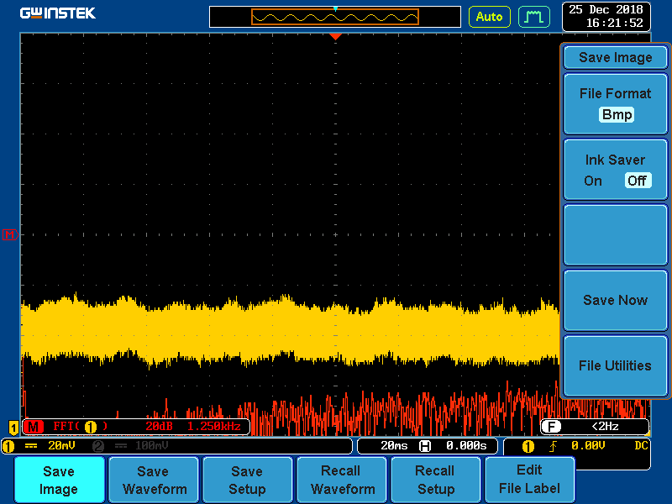

**Soru 4)**

8000 Hz örnekleme frekanslı 1700 Hz kesim frekanslı 12. Dereceden Chebyshev 2. Alçak geçiren filtre tasarladık. 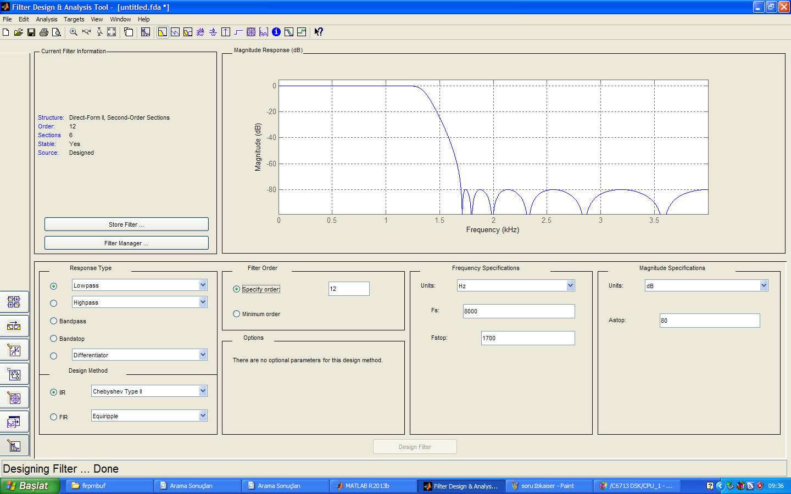

Aynı karakteristiğe sahip Butterworth filtresi tasarladık.Butterworth filtenin davranışı oldukça kötü oldu . 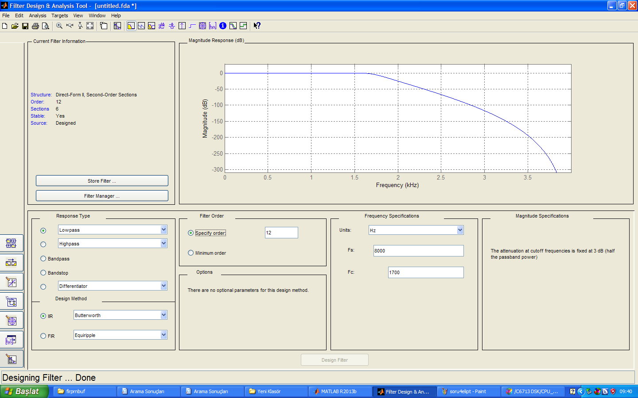

AA

EElEE

Elipti

a

Aynı karakteristikte Eliptik filtresi Chebyshev 2 ye göre geçiş bölgesi daha dik oldu . Durdurma bandı dalgalanması ise birbirine yakın sonuçlar verdi.

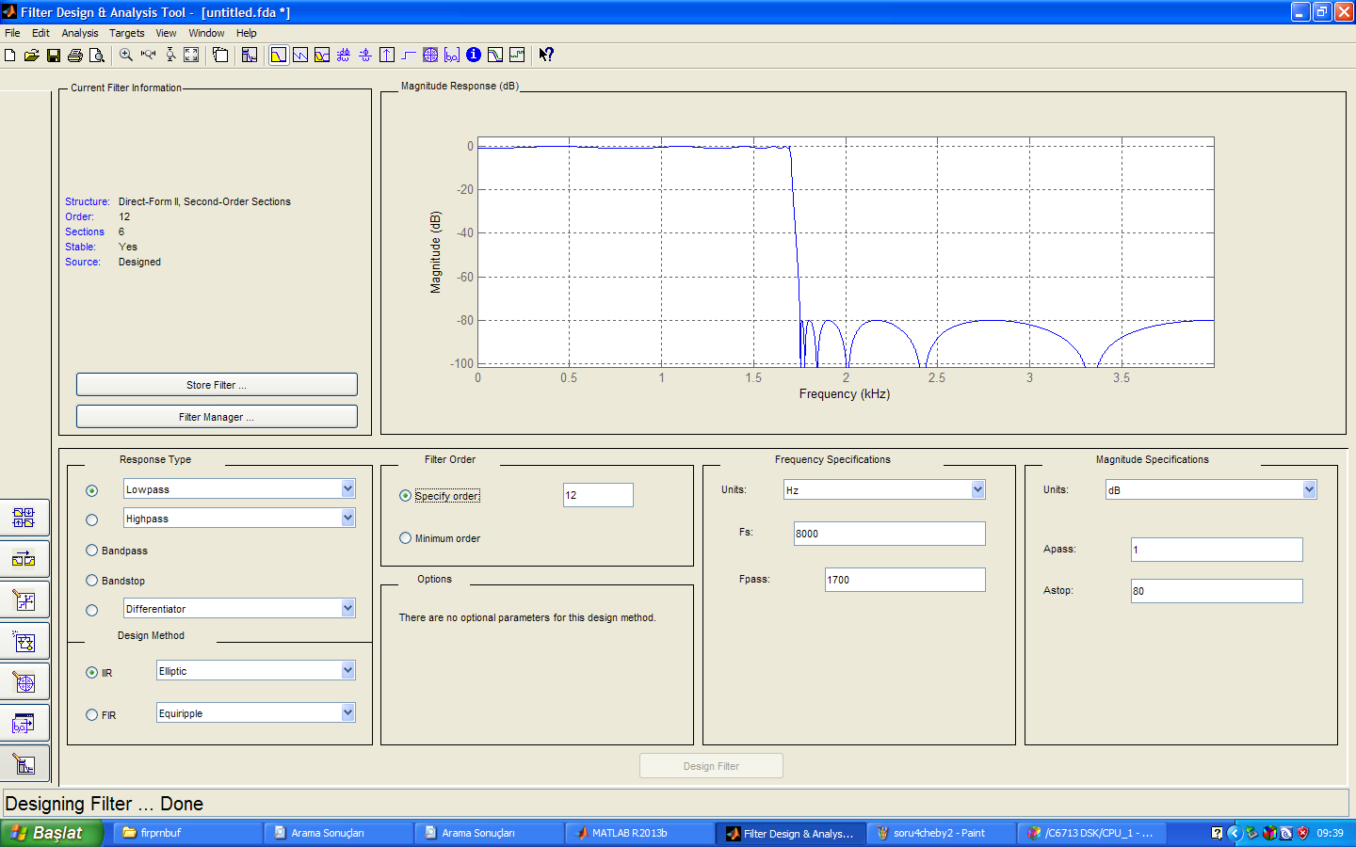

**Soru 5)**

3200 Hz den başlayıp 400 Hz de sıfırlayan bir fekansla azalan sinüs işareti üreten kodu yazdık.

#include "DSK6713_AIC23.h" //codec support

Uint32 fs=DSK6713_AIC23_FREQ_8KHZ; //set sampling rate

#define DSK6713_AIC23_INPUT_MIC 0x0015

#define DSK6713_AIC23_INPUT_LINE 0x0011

Uint16 inputsource=DSK6713_AIC23_INPUT_LINE; // select mic in

#include <math.h>

#define MIN_FREQ 400

#define MAX_FREQ 3200

#define STEP_FREQ 20

#define SWEEP_PERIOD 400

#define SAMPLING_FREQ 8000

#define AMPLITUDE 5000

#define PI 3.14159265358979

float y[3] = {0.0, 0.0, 0.0};

float a1;

float freq =MAX_FREQ ;

short sweep_count = 0;

void coeff_gen(float freq)

{

a1 = 2.0*cos(2.0*PI*freq/SAMPLING_FREQ);

y[0] = 0.0;

y[1] = sin(2.0*PI*freq/SAMPLING_FREQ);

y[2] = 0.0;

return;

}

interrupt void c_int11() //ISR

{

sweep_count++;

if (sweep_count >= SWEEP_PERIOD)

{

if (freq <= MIN_FREQ) freq = MAX_FREQ;

else freq -= STEP_FREQ;

coeff_gen(freq);

sweep_count = 0;

}

y[0] =(y[1]*a1)-y[2];

y[2] = y[1]; //update y1(n-2)

y[1] = y[0]; //update y1(n-1)

output_left_sample((short)(y[0]*AMPLITUDE)); //output result

return; //return to main

}

void main()

{

y[1] = sin(2.0*PI*freq/SAMPLING_FREQ);

a1 = 2.0*cos(2.0*PI*freq/SAMPLING_FREQ);

comm_intr(); //init DSK, codec, McBSP

while(1); //infinite loop

}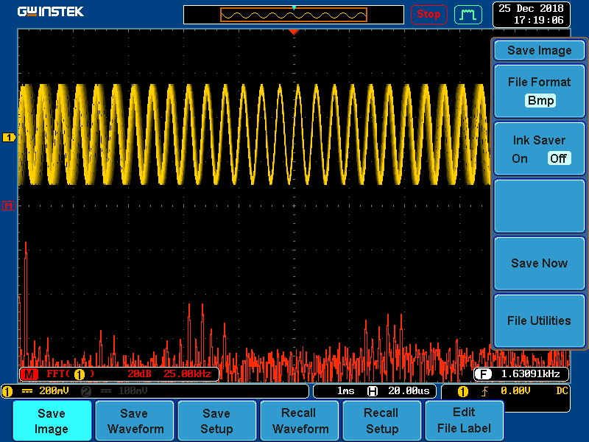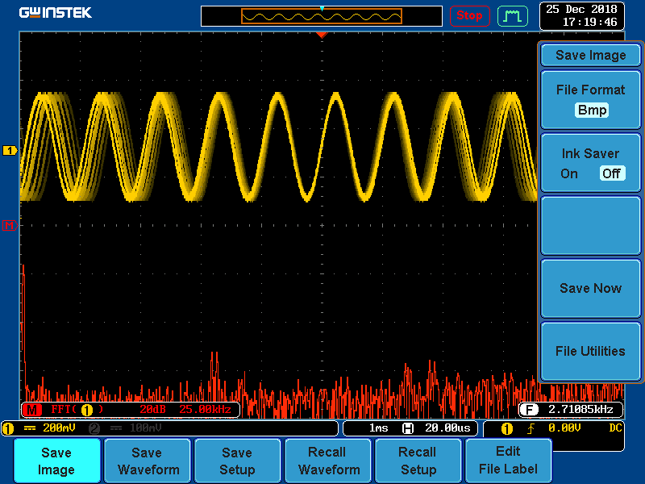

**Soru 6)**

2. dereceden 2 filte katsayılarını seri bağlayarak 4. Derceden IIR filtreyi elde ettik.

// iirsosprn.c generic iir filter using cascaded second order sections

// input from PRBS generator function, output to line out

// float coefficients read from included .cof file

#include "DSK6713_AIC23.h" //codec-DSK interface support

Uint32 fs=DSK6713_AIC23_FREQ_8KHZ; //set sampling rate

#define DSK6713_AIC23_INPUT_MIC 0x0015

#define DSK6713_AIC23_INPUT_LINE 0x0011

Uint16 inputsource=DSK6713_AIC23_INPUT_LINE;

#include "son.cof"

float w[NUM_SECTIONS][2] = {0};

float w1[NUM_SECTIONS][2] = {0};

#include "noise_gen.h" //support file for noise sequence generation

int fb; //feedback variable

shift_reg sreg; //shift register

#define NOISELEVEL 8000 //scale factor for +/- 1 noise sequence

int prand(void) //pseudo-random noise generation

{

int prnseq;

if(sreg.bt.b0)

prnseq = -NOISELEVEL; //scaled negative noise level

else

prnseq = NOISELEVEL; //scaled positive noise level

fb =(sreg.bt.b0)^(sreg.bt.b1); //XOR bits 0,1

fb^=(sreg.bt.b11)^(sreg.bt.b13); //with bits 11,13 -> fb

sreg.regval<<=1; //shift register 1 bit to left

sreg.bt.b0=fb; //close feedback path

return prnseq;

}

void resetreg(void)

{

sreg.regval = 0xFFFF; //shift register to nominal values

fb = 1; //initial feedback value

return;

}

interrupt void c_int11() //interrupt service routine

{

int section; // index for section number

float input; // input to each section

float wn,yn; // intermediate and output values in each stage

int section1; // index for section number

float input1; // input to each section

float wn1,yn1; // intermediate and output values in each stage

// intermediate and output values in each stage

// intermediate and output values in each stage

input =((float)prand()); // input to first section read from codec

for (section=0 ; section< NUM_SECTIONS ; section++)

{

wn = input - a[section][0]*w[section][0] - a[section][1]*w[section][1];

yn = b[section][0]*wn + b[section][1]*w[section][0] + b[section][2]*w[section][1];

w[section][1] = w[section][0];

w[section][0] = wn;

input = yn; // output of current section will be input to next

}

//output_left_sample((short)yn);

input1 =(yn); // input to first section read from codec

for (section1=0 ; section1< NUM_SECTIONS ; section1++)

{

wn1 = input1 - a1[section1][0]*w1[section1][0] - a1[section1][1]*w1[section1][1];

yn1 = b1[section1][0]*wn1 + b1[section1][1]*w1[section1][0] + b1[section1][2]*w1[section1][1];

w1[section1][1] = w1[section1][0];

w1[section1][0] = wn1;

input1 = yn1; // output of current section will be input to next

}

output_left_sample((short)yn1); // before writing to codec

return; //return from ISR

}

void main()

{

resetreg();

comm_intr(); //init DSK, codec, McBSP

while(1); //infinite loop

}

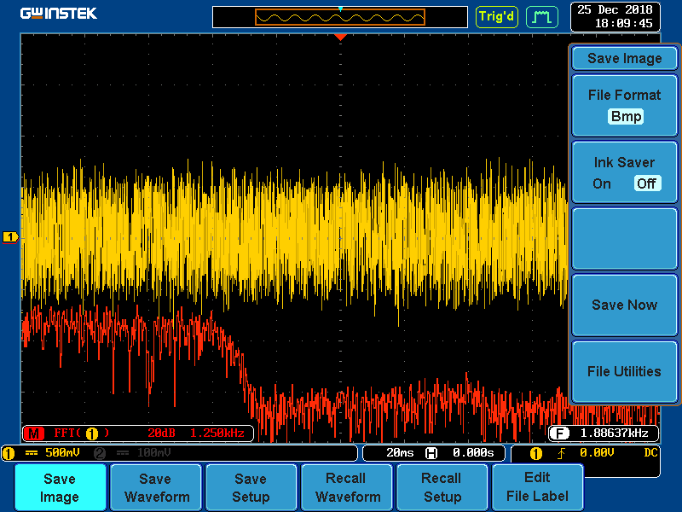^

2.dereceden 3 tane filtre katsayılarını seri bağlayarak 6.derecen filtre tasarladık.

// iirsosprn.c generic iir filter using cascaded second order sections

// input from PRBS generator function, output to line out

// float coefficients read from included .cof file

#include "DSK6713_AIC23.h" //codec-DSK interface support

Uint32 fs=DSK6713_AIC23_FREQ_8KHZ; //set sampling rate

#define DSK6713_AIC23_INPUT_MIC 0x0015

#define DSK6713_AIC23_INPUT_LINE 0x0011

Uint16 inputsource=DSK6713_AIC23_INPUT_LINE;

#include "son.cof"

float w[NUM_SECTIONS][2] = {0};

float w1[NUM_SECTIONS][2] = {0};

float w2[NUM_SECTIONS][2] = {0};

#include "noise_gen.h" //support file for noise sequence generation

int fb; //feedback variable

shift_reg sreg; //shift register

#define NOISELEVEL 8000 //scale factor for +/- 1 noise sequence

int prand(void) //pseudo-random noise generation

{

int prnseq;

if(sreg.bt.b0)

prnseq = -NOISELEVEL; //scaled negative noise level

else

prnseq = NOISELEVEL; //scaled positive noise level

fb =(sreg.bt.b0)^(sreg.bt.b1); //XOR bits 0,1

fb^=(sreg.bt.b11)^(sreg.bt.b13); //with bits 11,13 -> fb

sreg.regval<<=1; //shift register 1 bit to left

sreg.bt.b0=fb; //close feedback path

return prnseq;

}

void resetreg(void)

{

sreg.regval = 0xFFFF; //shift register to nominal values

fb = 1; //initial feedback value

return;

}

interrupt void c_int11() //interrupt service routine

{

int section; // index for section number

float input; // input to each section

float wn,yn; // intermediate and output values in each stage

int section1; // index for section number

float input1; // input to each section

float wn1,yn1; // intermediate and output values in each stage

int section2; // index for section number

float input2; // input to each section

float wn2,yn2; // intermediate and output values in each stage

// intermediate and output values in each stage

input =((float)prand()); // input to first section read from codec

for (section=0 ; section< NUM_SECTIONS ; section++)

{

wn = input - a[section][0]*w[section][0] - a[section][1]*w[section][1];

yn = b[section][0]*wn + b[section][1]*w[section][0] + b[section][2]*w[section][1];

w[section][1] = w[section][0];

w[section][0] = wn;

input = yn; // output of current section will be input to next

}

//output_left_sample((short)yn);

input1 =(yn); // input to first section read from codec

for (section1=0 ; section1< NUM_SECTIONS ; section1++)

{

wn1 = input1 - a1[section1][0]*w1[section1][0] - a1[section1][1]*w1[section1][1];

yn1 = b1[section1][0]*wn1 + b1[section1][1]*w1[section1][0] + b1[section1][2]*w1[section1][1];

w1[section1][1] = w1[section1][0];

w1[section1][0] = wn1;

input1 = yn1; // output of current section will be input to next

}

input2 =(yn1); // input to first section read from codec

for (section2=0 ; section2< NUM_SECTIONS ; section2++)

{

wn2 = input2 - a2[section2][0]*w2[section2][0] - a2[section2][1]*w2[section2][1];

yn2 = b2[section2][0]*wn2 + b2[section2][1]*w2[section2][0] + b2[section2][2]*w2[section2][1];

w2[section2][1] = w2[section2][0];

w2[section2][0] = wn2;

input2 = yn2; // output of current section will be input to next

}

output_left_sample((short)yn2); // before writing to codec

return; //return from ISR

}

void main()

{

resetreg();

comm_intr(); //init DSK, codec, McBSP

while(1); //infinite loop

}

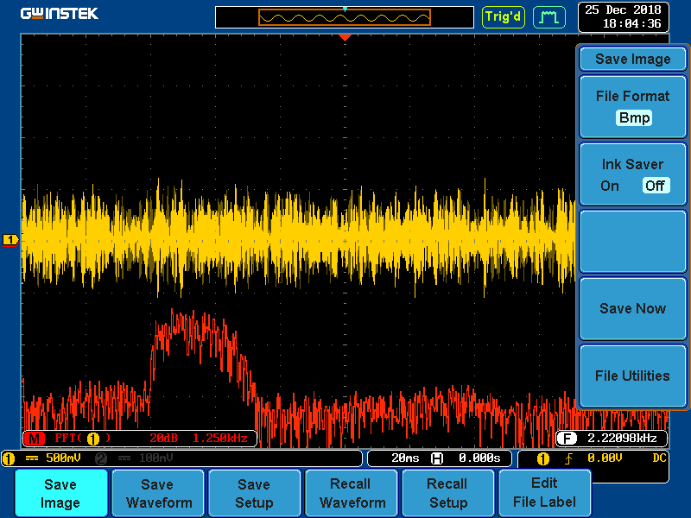

2.dereceden 4 tane filtre katsayılarını seri bağlayarak 8. Dereceden filtre elde ettik. // iirsosprn.c generic iir filter using cascaded second order sections

// input from PRBS generator function, output to line out

// float coefficients read from included .cof file

#include "DSK6713_AIC23.h" //codec-DSK interface support

Uint32 fs=DSK6713_AIC23_FREQ_8KHZ; //set sampling rate

#define DSK6713_AIC23_INPUT_MIC 0x0015

#define DSK6713_AIC23_INPUT_LINE 0x0011

Uint16 inputsource=DSK6713_AIC23_INPUT_LINE;

#include "impinv.cof"

float w[NUM_SECTIONS][2] = {0};

float w1[NUM_SECTIONS][2] = {0};

float w2[NUM_SECTIONS][2] = {0};

float w3[NUM_SECTIONS][2] = {0};

#include "noise_gen.h" //support file for noise sequence generation

int fb; //feedback variable

shift_reg sreg; //shift register

#define NOISELEVEL 8000 //scale factor for +/- 1 noise sequence

int prand(void) //pseudo-random noise generation

{

int prnseq;

if(sreg.bt.b0)

prnseq = -NOISELEVEL; //scaled negative noise level

else

prnseq = NOISELEVEL; //scaled positive noise level

fb =(sreg.bt.b0)^(sreg.bt.b1); //XOR bits 0,1

fb^=(sreg.bt.b11)^(sreg.bt.b13); //with bits 11,13 -> fb

sreg.regval<<=1; //shift register 1 bit to left

sreg.bt.b0=fb; //close feedback path

return prnseq;

}

void resetreg(void)

{

sreg.regval = 0xFFFF; //shift register to nominal values

fb = 1; //initial feedback value

return;

}

interrupt void c_int11() //interrupt service routine

{

int section; // index for section number

float input; // input to each section

float wn,yn; // intermediate and output values in each stage

int section1; // index for section number

float input1; // input to each section

float wn1,yn1; // intermediate and output values in each stage

int section2; // index for section number

float input2; // input to each section

float wn2,yn2; // intermediate and output values in each stage

int section3; // index for section number

float input3; // input to each section

float wn3,yn3; // intermediate and output values in each stage

input =((float)prand()); // input to first section read from codec

for (section=0 ; section< NUM_SECTIONS ; section++)

{

wn = input - a[section][0]*w[section][0] - a[section][1]*w[section][1];

yn = b[section][0]*wn + b[section][1]*w[section][0] + b[section][2]*w[section][1];

w[section][1] = w[section][0];

w[section][0] = wn;

input = yn; // output of current section will be input to next

}

//output_left_sample((short)yn);

input1 =(yn); // input to first section read from codec

for (section1=0 ; section1< NUM_SECTIONS ; section1++)

{

wn1 = input1 - a1[section1][0]*w1[section1][0] - a1[section1][1]*w1[section1][1];

yn1 = b1[section1][0]*wn1 + b1[section1][1]*w1[section1][0] + b1[section1][2]*w1[section1][1];

w1[section1][1] = w1[section1][0];

w1[section1][0] = wn1;

input1 = yn1; // output of current section will be input to next

}

input2 =(yn1); // input to first section read from codec

for (section2=0 ; section2< NUM_SECTIONS ; section2++)

{

wn2 = input2 - a2[section2][0]*w2[section2][0] - a2[section2][1]*w2[section2][1];

yn2 = b2[section2][0]*wn2 + b2[section2][1]*w2[section2][0] + b2[section2][2]*w2[section2][1];

w2[section2][1] = w2[section2][0];

w2[section2][0] = wn2;

input2 = yn2; // output of current section will be input to next

}

input3 =(yn2); // input to first section read from codec

for (section3=0 ; section3< NUM_SECTIONS ; section3++)

{

wn3 = input3 - a3[section3][0]*w3[section3][0] - a3[section3][1]*w3[section3][1];

yn3 = b3[section3][0]*wn3 + b3[section3][1]*w3[section3][0] + b3[section3][2]*w3[section3][1];

w3[section3][1] = w3[section3][0];

w3[section3][0] = wn3;

input3 = yn3; // output of current section will be input to next

}

output_left_sample((short)yn3); // before writing to codec

return; //return from ISR

}

void main()

{

resetreg();

comm_intr(); //init DSK, codec, McBSP

while(1); //infinite loop

}

